Git Tag
Tagging lets developers mark important checkpoints in the course of their projects' development. For instance, software release versions can be tagged. (Ex: v1.3.2) It essentially allows you to give a commit a special name (tag).
To view/list all the created tags:

git tag
Example:-
$ git tag
v1.0
v2.0

Currently I don’t have any tags
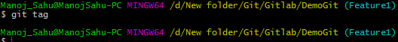

Creating Tags:

To create a new tag execute the following command:

git tag <tagname>

I have created a new tag v1.0 now as below
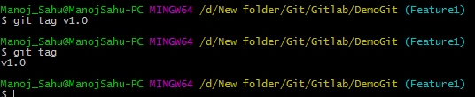

By default git tag is associated with latest commit if no checksum is given

Git supports two types of tags: lightweight and annotated.

Annotated Tags:

Annotated tags are stored as full objects in the Git database. To reiterate, They store extra meta data such as: the tagger name, email, and date. Similar to commits and commit messages.

Additionally, for security, annotated tags can be signed and verified with GNU Privacy Guard (GPG).

To create an anotated tag, add -a tagname -m "tag message" to the git tag command:

Ex:
$ git tag -a v4.0 -m "release version 4.0"

Lightweight Tags:
Lightweight tags contain only the commit checksum (no other information is stored). Lightweight tags are created with the absence of the -a, -s, or -m options. Lightweight tags create a new tag checksum and store it in the .git/ directory of the project's repo.
Ex:
$ git tag v4.1-lw

View tag’s data
You can run the git show command to view the data stored in a tag.
If the tag you are watching is a lightweight tag, you’ll only see the refered commit data:
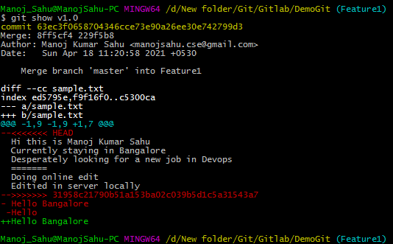
Created new annotated tag
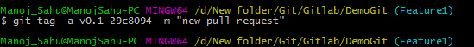
You can see the tag data along with the commit that was tagged by using the git show command:
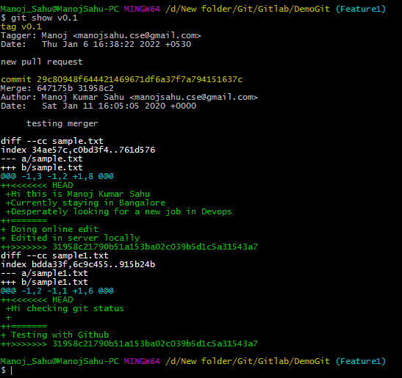

Tagging Old Commits:
You can also tag past commits using the git tag commit. In order to do this, you’ll need to specify the commit’s checksum (or at least a part of it) in the command’s line.

First, run git log to find out the required commit’s checksum:
$ git log --pretty=oneline
ac2998acf289102dba00823821bee04276aad9ca added products section
d09034bdea0097726fd8383c0393faa0072829a7 refactorization
a029ac120245ab012bed1ca771349eb9cca01c0b modified styles
da43a5f7389adcb9201ab0a289c389ed022a910b finished details
0adb03ca013901c1e02174924486a08cea9293a2 small fix in search textarea styles

When you have the checksum needed, add it at the end of the tag creation line:
git tag -a v3.5 a029ac
Or
git tag -a v1.2 a029ac120245ab012bed1ca771349eb9cca01c0b

Sharing: Pushing Tags to Remote:
Sharing tags is similar to pushing branches. By default, git push will not push tags. Tags have to be explicitly passed to git push.
Syntax:
git push origin <tagname>.
Or
Git push origin –tags -> to push all tags at a time
I pushed my tag v1.0 to remote as below
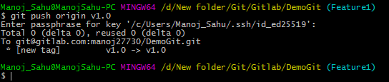

Now in Gitlab under tags it can be viewed
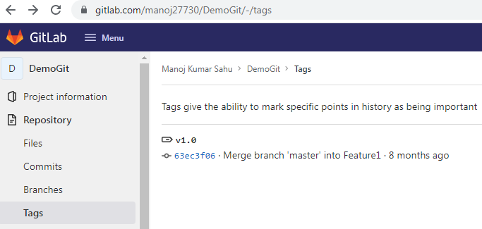
Pushing all tags to remote simultaneously
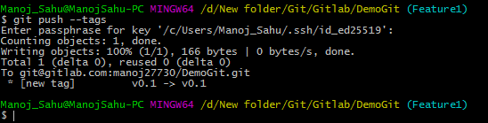
Now in Gitlab you can see two tags
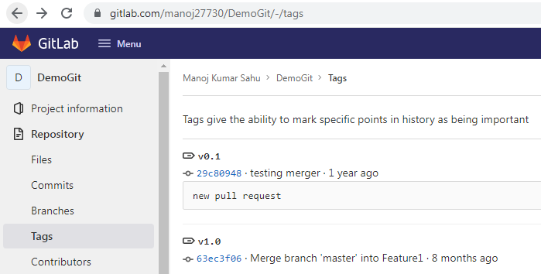

Deleting Tags:
To delete a tag on your local repository
Syntax :- git tag -d <tagname>
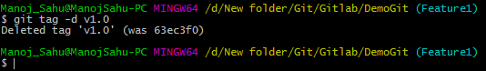
Note that this does not remove the tag from any remote servers.

To delete a tag from a remote server

Syntax:- git push origin --delete <tagname>
Or git push origin –d <tagname>
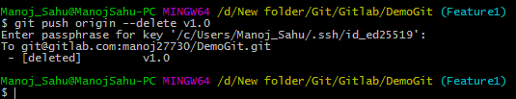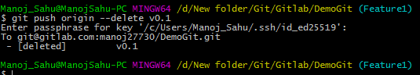

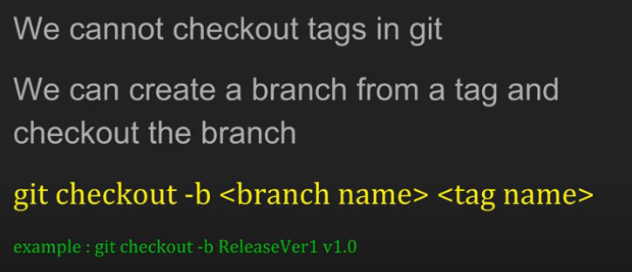

To refine the list of tags the -l option can be passed with a wild card expression:

